Sample title for JRN manuscript: Sample sub-title

Type of Manuscript: [ARTICLE] Original Article (Select the type of manuscript)

Author(s)
Torayasu AMARI¹, Masakage YAMAGATA^{2,3}, John DOE^{1,3} (Add the number of authors' institution in superscript. Numbering is needed even if there is only one author.)
Affiliation(s)
- Division of AAA, Research Institute of BBB
- Department of Red Arms, Takeda-clan University
- OPQR-kai Rehabilitation Hospital

Correspondence
Masakage YAMAGATA, MD, PhD (m.yamagata@takeda-clan.univ.ac.jp), Department of Red Arms, Takeda-clan University, 1062 Yatsukaho, Shinshiro, Aichi 441-1318, Japan.

Remove this box before submitting!
This template is for Original Article, Brief Report, and Research Note.

Blue highlighted text should be replaced or removed with your own information with black text.

For full guidance, please see “Submission Guideline for the Journal of Rehabilitation Neurosciences” https://nourehaken.jp/pdf/Submission_Guideline_Eng.pdf
Abstract
In the abstract, do not include headings such as “Results” and do not insert line breaks. If the author does not include a native English speaker, an English proofreading certificate is required for publication.

Keywords: cerebrovascular disease, spinal cord injury, mental practice, sample, test (Describe 3 to 5 keywords separated by commas.)

Main Text (Introduction - Conflicts of Interest)
- Introduction
Original Article, Brief Report, and Research Note basically consist of the following chapters: 1 Introduction, 2 Materials and Methods, 3 Results, 4 Discussion, 5 Conclusion, 6 Acknowledgments (If relevant), 7 Ethics Approval (If relevant), and 8 Conflicts of Interest. “Introduction”, “Conclusion”, and “Conflicts of Interest” are mandatory regardless of the type of manuscript.
In the Introduction section, the authors should provide readers with the background information needed to understand your study. This section should be built on previous studies.

  - Caption
When layering the captions, use “1.1”, “1.2”, “1.1.1”, “1.1.2”, …

  - Section
Section example

    - Subsection
Subsection example

  - Maximum amount of words
Length of main text (excluding abstract, references, and figure legends), number of tables/figures, and number of references are limited as the follows:
- Original Article 4,800 words in main text, 8 tables/figures, and 40 references.
- Brief Report 3,600 words in main text, 6 tables/figures, and 30 references.
- Research Note 2,400 words in main text, 4 tables/figures, and 20 references.

  - Basic format in Main text
Text in the “Main Text” should be typed using 10.5-points Times New Roman in single column. Use American English spelling. When using abbreviations, use standard abbreviations and write the full spelling at first appearing. In principle, units of the International System of Units (SI) should be used to express the values of quantities.

  - Basic format in References
We encourage authors to use the EndNote (Clarivate Analytics, https://endnote.com/). The EndNote style file for JRN can be downloaded from the homepage of Japanese Society for Brain Function and Rehabilitation (https://nourehaken.jp/journal_en/).
The previous studies listed in “References” must be cited in the main text and/or figures/tables. For full guidance, please see “Submission Guidelines for the Journal of Rehabilitation Neurosciences”. https://nourehaken.jp/pdf/Submission_Guideline_Eng.pdf

- Materials and Methods
This section should provide enough detail that the experiments can be reproduced by others.

- Results
This section is where you report the findings of the study based on the methods described in the "Materials and Methods" section. There should not be any discussion.

- Discussion
In this section, it is necessary to describe the central results and potential implications of your study in light of what was already known in previous studies. This section is also meant to highlight how it contributes to the knowledge in the rehabilitation field.

- Conclusion
In this section, the authors should state clearly the main conclusions which relate back directly to the questions posed in the Introduction section.

Acknowledgments (If relevant)
In this section, acknowledge anyone who contributed to this manuscript but does not meet the criteria for authorship. The source of any financial support received for your study being published must be specified.

Ethics Approval (If relevant)
Ethical considerations such as explanation and consent should be described in this section, not in the “Materials and Methods” section. Include the name of approving committee and approval number.
Based on the Declaration of Helsinki including subsequent revisions and supplements, pay sufficient attention to the protection of the subject.

Conflicts of Interest
Profits from companies do not affect the acceptance of papers in principle. If there is no conflict of interest, please state "The authors have no conflicts of interest directly relevant to the content of this article".

References
1. Shimoda N, Takeda K, Imai I, Kaneko J, Kato H. Cerebral laterality differences in handedness: a mental rotation study with NIRS. Neurosci Lett. 2008; 430(1): 43-7.
2. Moore BCJ. An Introduction to the Psychology of Hearing. 6th ed. Leiden: BRILL; 1985. p. 133-68.
3. Takahashi M, Takeda K, Otaka Y, Osu R, Hanakawa T, Gouko M, et al. Event related desynchronization-modulated functional electrical stimulation system for stroke rehabilitation: A feasibility study. J Neuroeng Rehabil. 2012; 9: 56.
4. http://jipsti.jst.go.jp/sist/handbook/sist08_2010/main.htm [cited 2018 August 31].
5. Zifkin BG, Cracco RQ. An Orderly Approach to the Abnormal Electroencephalogram. In: Ebersole JS, Pedley TA, editors. Current Practice of Clinical Electroencephalography. 3rd ed. Philadelphia: Lippincott Williams & Wilkins; 2003. p. 288-302.

Remove this box before submitting!

We encourage authors to use the EndNote (Clarivate Analytics, https://endnote.com/). The EndNote style file for JRN can be downloaded from the homepage of Japanese Society for Brain Function and Rehabilitation (https://nourehaken.jp/journal_en/).

For full guidance, please see “Submission Guideline for the Journal of Rehabilitation Neurosciences” https://nourehaken.jp/pdf/Submission_Guideline_Eng.pdf
Figure(s) and Figure Legend(s)

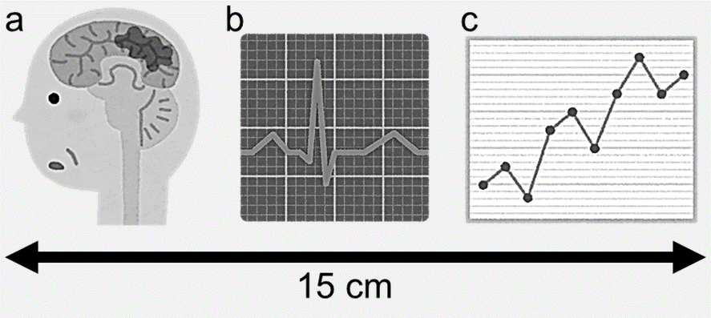

Figure 1: Figure title.

The figure must be mentioned in the main text. Paste an image with a width of 7.5 cm or 15 cm in the manuscript. When displaying multiple graphs or photos in a single figure, display “a”, “b”, etc. on the left shoulder of each graph or photo. Write the figure title below the pasted image, left-justified, as “Figure 1: Figure title” (“Figure 1:” is bold) and the description below the title. When displaying multiple graphs etc., describe the explanatory text for each graph as follows: “(a) Text for the first graph, (b) Text for the second graph”. Text in the “Figures” and “Figure Legends” should be typed using Arial or Helvetica. The font size in the figures should be adjusted to an appropriate size assuming the printed size. If an abbreviation appears in the figure, write the full spelling in the figure legend even if it has already been mentioned in the main text. Unless there is a special reason, use a grayscale figure without color including a photograph. The numbering is needed even if there is only one figure.

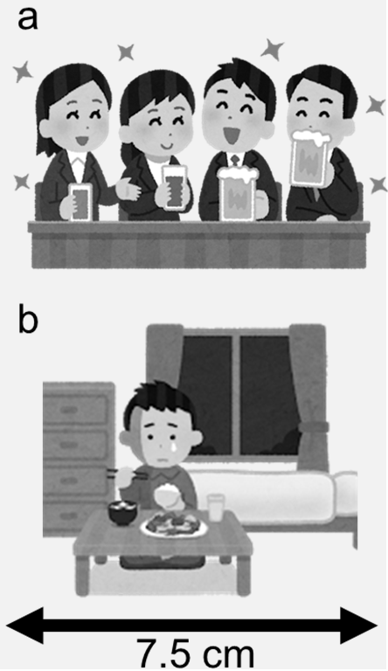

Figure 2: Figure title

This figure shows a sample image with a width of 7.5 cm.

Table(s)

Table 1: Table Title
Make the table editable, not images
 |  | 1) | Write the table title at the top of the table, left-justified.
 |  | 2) | The numbering is needed even if there is only one table.
 |  | 3) | Avoid ruled lines (especially vertical lines) as much as possible.
 |  | 4) | Keep the ruled line thickness constant and do not mix ruled lines with different thicknesses.
 | Font
 |  | 1) | “Table 1:” is bold
 |  | 2) | Text in the “Tables” should be typed using Arial or Helvetica.
The table must be mentioned in the main text. If an abbreviation appears in the table, write the full spelling in the bottom of the table even if it has already been mentioned in the main text.

Table 2: Table Sample
Type | I (n=20) | II (n=13) | III (n=23) | IV (n=22) | V (n=8)
Age (years)† | 60.0±13.2 | 58.7±13.9 | 55.8±13.5 | 54.5±12.7 | 64.9±14.0
Sex (M/F) | 10/10 | 9/4 | 13/10 | 10/12 | 4/4
Time since stroke onset (days)† | 30.0±12.0 | 29.8±12.1 | 26.5±13.2 | 29.9±11.2 | 32.7±12.5
Hematoma Volume (mL)† | 10.4±8.6 | 20.9±15.4 | 30.5±15.0 | 50.4±19.2 | 80.0±14.2*
Lesion Side (R/L) | 7/13 | 6/7 | 9/14 | 13/9 | 5/3
*The volume of type V hematoma was significantly larger than those of types I - IV. †Mean ± standard deviation. M, male; F, female; R, right; L, left.

Copyright

Copyright © 2023 Torayasu AMARI, PhD, et al. This is an open-access article distributed under the terms of the Creative Commons Attribution License. The use, distribution, and reproduction in any medium are permitted, provided the original author(s) and source are credited in accordance with accepted academic practice.
Remove this box before submitting!

For copyright notice, please replace the blue characters with Name, Profession, and Degree of the first author.

